CYB 210 5-2 Activity: Packet Tracer
Andree Salvo
Southern New Hampshire University
CYB 210
Instructor: Bruce Gonzalez
3/1/2025
2025
- Change network addressing (subnet masks, IP addressing, and default gateway) for the new network configuration.
Provide an explanation: Configured all 4 IPV4 and default gateway to PC1, PC2,PC3, to the correct addresses.
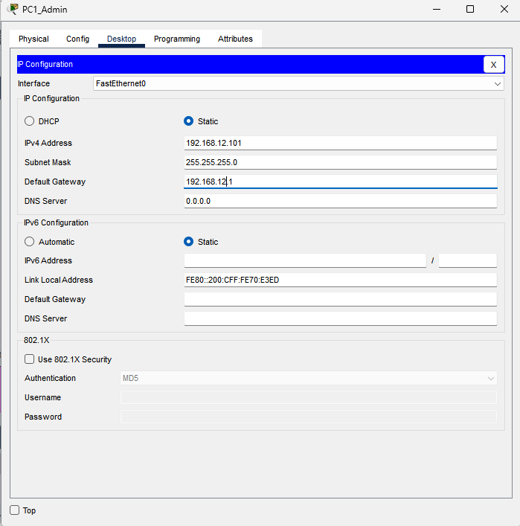

- Change RIP to accommodate two new network configurations. Submit a screenshot of the RIP Configuration dialog window and a

Given explanation:
    - I opened the Subnet Router.
    - I clicked CLI.
    - I typed the following input on the CLI console to connect to the new network configurations that was provided for me on the new spreadsheet.
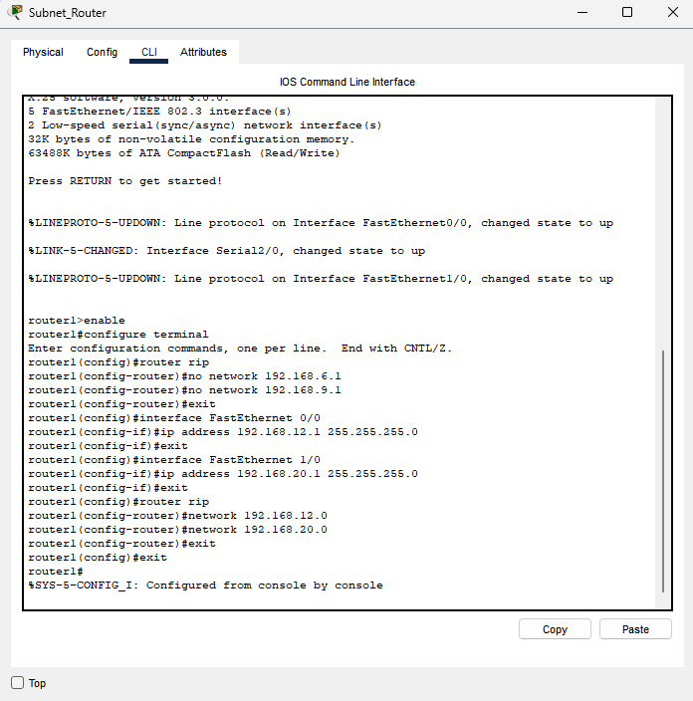

- Configure NAT on the router. Submit a screenshot of the NAT translations table and a brief explanation of the steps you took.

Explanation:
- Open the Subnet Router
- Click the CLI
- The commands I used to set the IP addresses from inside and outside was
- router1>enable
- router1#configure terminal
- Enter configuration commands, one per line. End with CNTL/Z.
- router1(config)#interface FastEthernet 0/0
- router1(config-if)#ip address 192.168.12.1 255.255.255.0
- router1(config-if)#ip nat inside
- router1(config-if)#interface FastEthernet1/0
- router1(config-if)#ip nat outside
- router1(config-if)#ip nat inside source static 192.168.12.1 192.168.20.1
- router1(config)#exit
- router1#
- %SYS-5-CONFIG_I: Configured from console by console

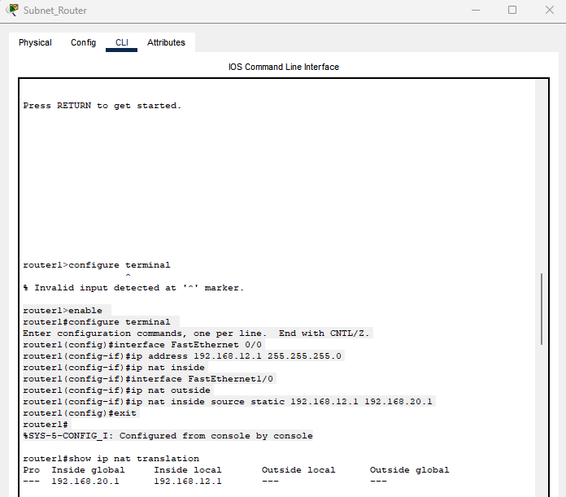
Also, I pinged both the Ip addresses to make sure they were a success.

(PART OF) Configure NAT
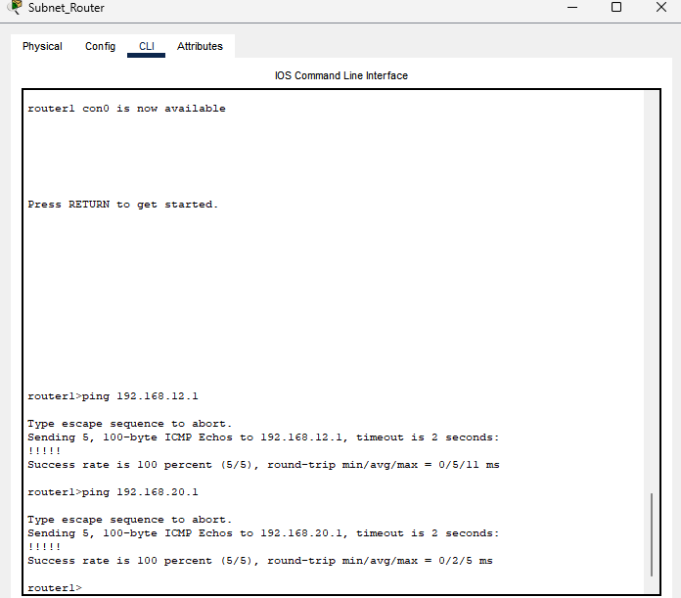

- Configure DHCP services
Explanation:
- Created a StudentPool
- Turned the services Off to On
- Configured the default gateway to 192.168.20.1
- Configured the DNS Server to 192.168.20.100
- Start IP Address: 192.168.20.125
- Change the max of users: 37
- Once Finished, I clicked on every StudentPC to check and it successfully assigned the correct IP addresses to each PC and device that are in range.
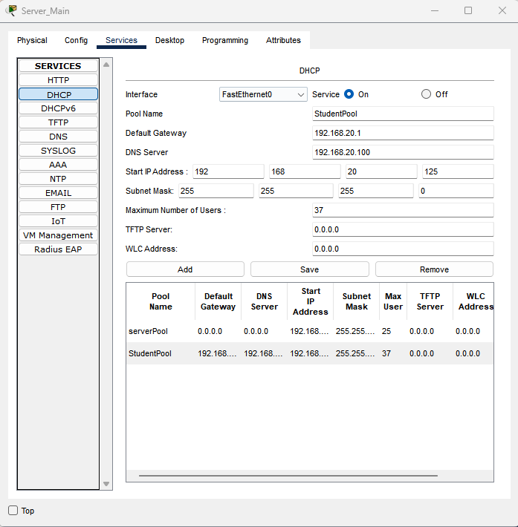

Second screenshot of PC2
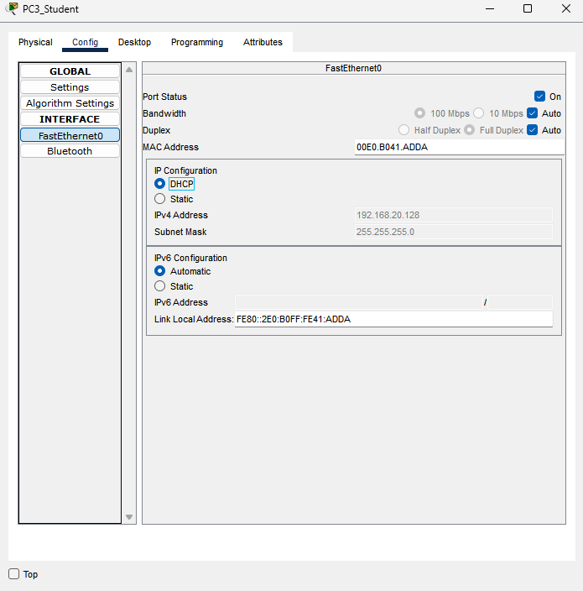

- Configure DNS for the server name and IP address
Explanation:
- Click Student Server Main
- Once in, go to Services
- In Services, click DNS
- Once in, Remove the first server.com
- Turn the DNS Service to ON
- Add a server
- Name – Server.com
- Type = A Record
Photo below
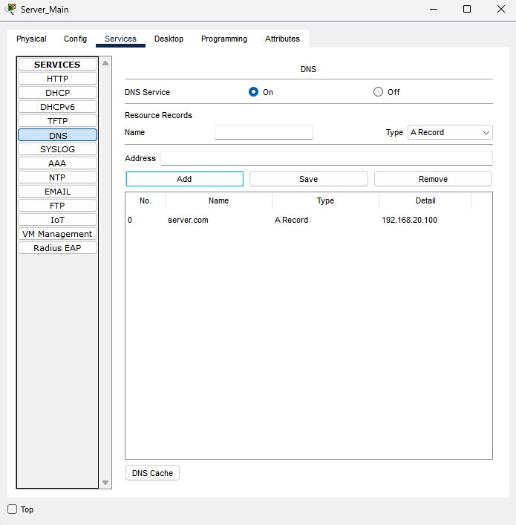
- Label all devices and networks with the IP addresses
